Deep learning is a branch of machine learning which is based on artificial neural networks. It is capable of learning complex patterns and relationships within data. In deep learning, we don’t need to explicitly program everything. It has become increasingly popular in recent years due to the advances in processing power and the availability of large datasets. Because it is based on artificial neural networks (ANNs) also known as deep neural networks (DNNs)

**What is Deep Learning?**

Deep learning is the branch of [machine learning](https://www.geeksforgeeks.org/machine-learning/) which is based on artificial neural network architecture. An artificial neural network or ANN uses layers of interconnected nodes called neurons that work together to process and learn from the input data.

In a fully connected Deep neural network, there is an input layer and one or more hidden layers connected one after the other. Each neuron receives input from the previous layer neurons or the input layer. The output of one neuron becomes the input to other neurons in the next layer of the network, and this process continues until the final layer produces the output of the network. The layers of the neural network transform the input data through a series of nonlinear transformations, allowing the network to learn complex representations of the input data.

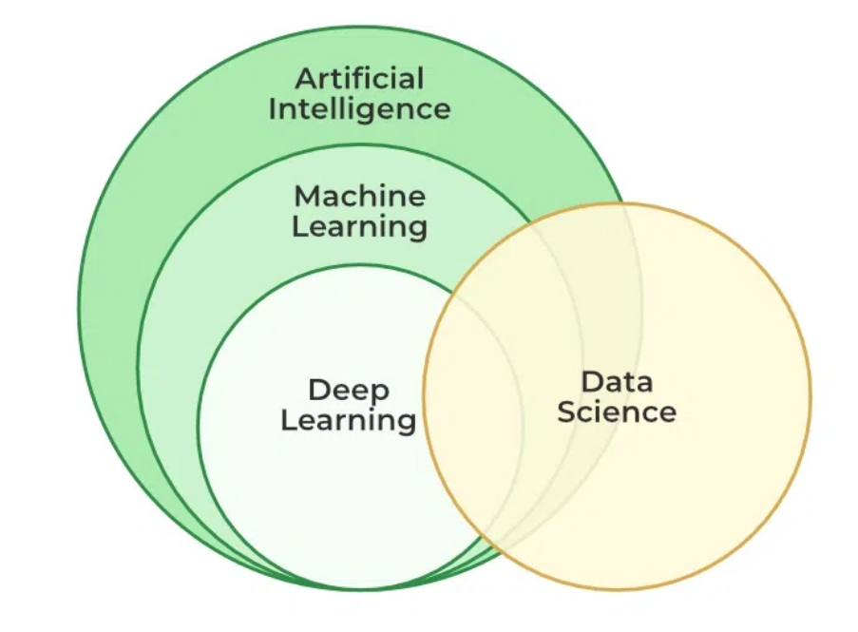

| **Machine Learning** | **Deep Learning** |
| --- | --- |
| Apply statistical algorithms to learn the hidden patterns and relationships in the dataset. | Uses artificial neural network architecture to learn the hidden patterns and relationships in the dataset. |
| Can work on the smaller amount of dataset | Requires the larger volume of dataset compared to machine learning |
| Better for the low-label task. | Better for complex task like image processing, natural language processing, etc. |
| Takes less time to train the model. | Takes more time to train the model. |
| A model is created by relevant features which are manually extracted from images to detect an object in the image. | Relevant features are automatically extracted from images. It is an end-to-end learning process. |
| Less complex and easy to interpret the result. | More complex, it works like the black box interpretations of the result are not easy. |